BSI IT-GS Compliance for Log360
Strengthen cybersecurity and meet BSI IT-GS compliance with Log360.
Region: Germany, International | Type: Cybersecurity Framework, Government/Public Sector, Industry Standard | Category: Compliance | Pricing: Free

Overview
The BSI IT-GS compliance extension in Log360 helps organizations meet BSI IT-Grundschutz, Germany's comprehensive IT baseline protection methodology from the Federal Office for Information Security applicable to organizations implementing an ISMS aligned with ISO 27001 by providing centralized log management, real-time threat detection, and automated security monitoring. The platform supports BSI IT-GS requirements for identity and access management, privileged account control, system logging, intrusion detection, network security, file integrity monitoring, vulnerability management, and cloud service security.
For Identity and Access Management (ORP.4), Log360 tracks Windows and Unix logon events, Active Directory authentication, remote desktop sessions, and user access patterns to demonstrate access control compliance. To address Privileged Account and Admin Control (ORP.4), the platform monitors user group changes, account lifecycle events, SUDO command executions, password enforcement, and administrative actions across Active Directory, Windows, and Unix platforms. The extension also supports System Logging and Event Monitoring (DER.1) by providing capabilities that centralizes Windows event logs, process tracking records, policy change events, GPO audit trails, and computer auditing data to maintain the required comprehensive log inventory.

Key Features
- Intrusion Detection and Threat Response (DER.2): Log360 provides automated threat detection from antivirus alerts, FireEye and Trend Micro threat feeds, Unix threat events, and network attack reports with correlation-based alerting for incident response.
- Network and Perimeter Security (NET.1): Log360 captures network device rule changes, configuration events, firewall security reports, attack attempts, and perimeter activity across all network infrastructure components.
- Data and File Integrity Monitoring (OPS.1.2.6): Log360 tracks file system changes, access failures, permission modifications, removable media usage, and Windows registry changes to detect data integrity violations in real time.
- Database and Application Auditing (SYS.1.1 / APP.3.1): Log360 monitors SQL Server, Oracle, and web application logs to detect unauthorized data access, schema changes, and application-level security violations, maintaining the integrity and availability of critical business systems

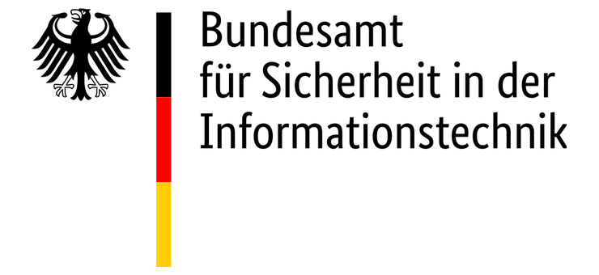
.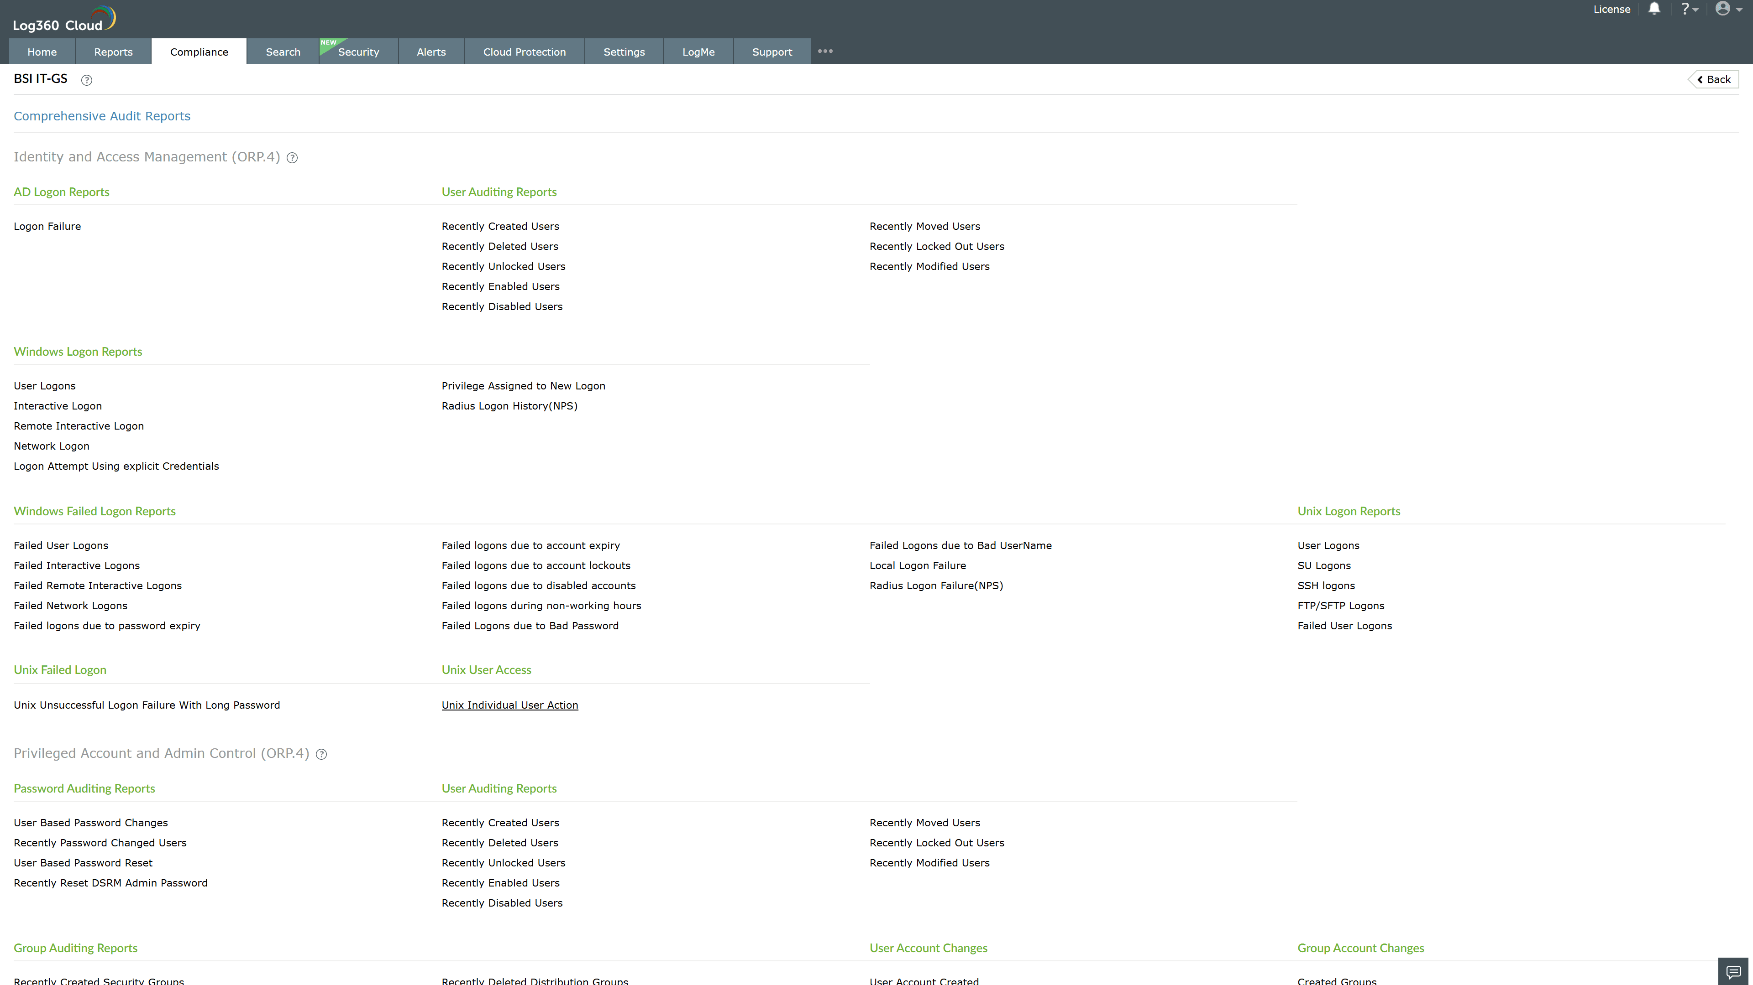
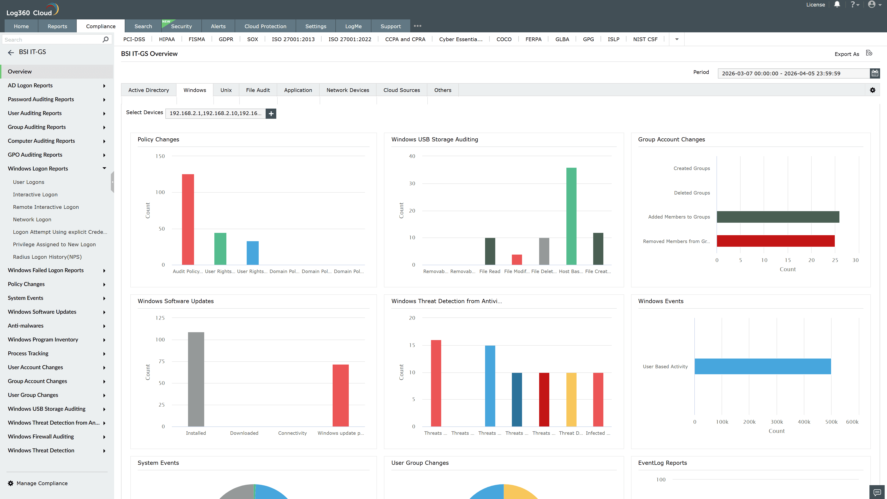
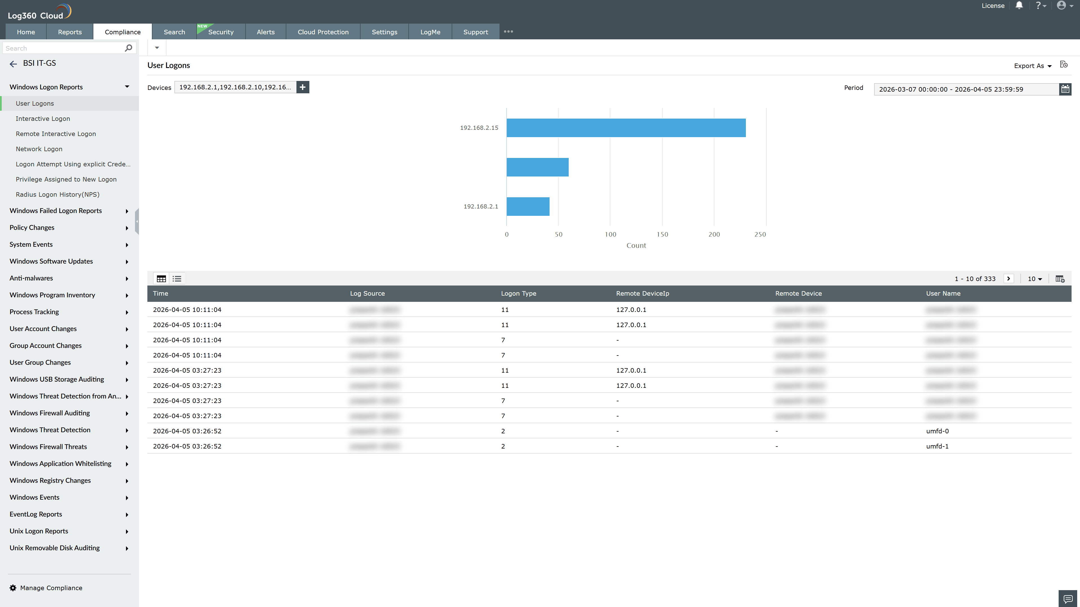
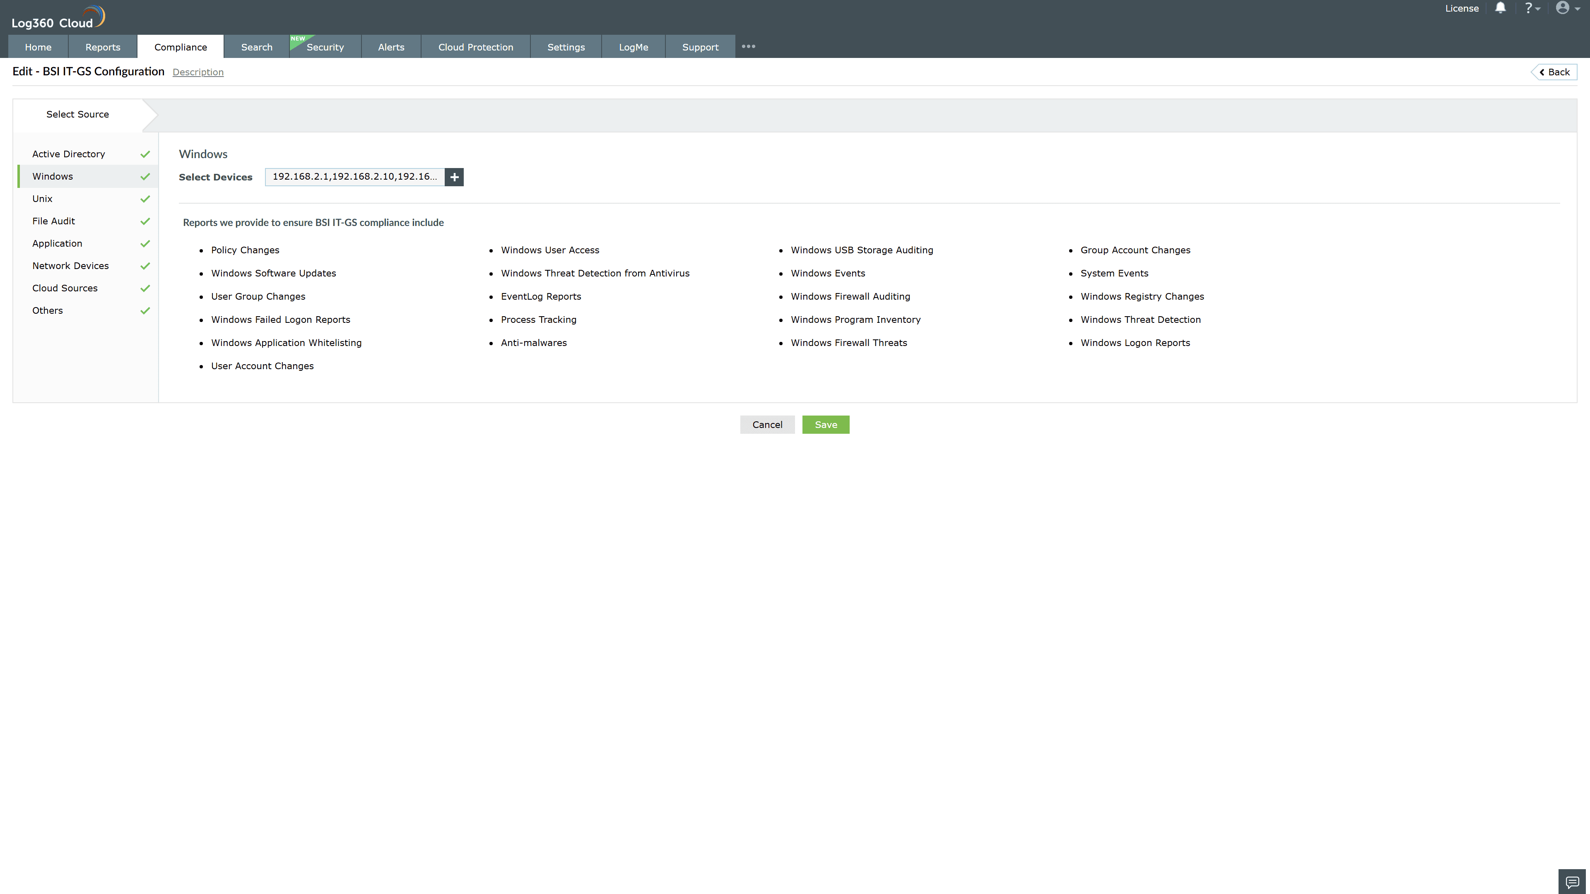
Valid Submission : Yes
Supported Editions : Free, Basic, Standard, Professional, MSSP
Help Document : https://www.manageengine.com/log-management/help/integrations/compliance-extensions.html
Help Video : Not provided
Tags : Log360, Compliance, Privacy monitoring, Data privacy, Regulatory compliance
Supported DCs : US, IN, JP, CA, AU, UK and EU
Privacy Policy:
Terms of Service:
Release Notes:
Predefined reports for the BSI IT-GS.

